
COMSATS University Islamabad, Abbottabad Campus
Department of Computer Science
Project Proposal
Instant Food Delivery
CSC392 Object Oriented Software Engineering

Group Member:
Ahsan Ali (SP20-BSE-060).
Asher Khan Swati (SP21-BSE-044).Team Leader…

Table of Contents

CHAPTER 1 PROJECT PROPOSAL 3
INTRODUCTION: 3
Vision and Business Case: 4
Use-Case Model 4
Supplementary Specification(Asher Khan Swati sp21-bse -044) 5
Glossary 5
Risk List & Risk Management Plan(Asher Khan Swati sp21-bse -044) 6
Brief level use case: 7
Asher khan swati (SP21-BSE-044) 7
Ahsan Ali (SP20-BSE-060) 7
Use Case: 1_ Order 7
Use Case: 2_Menu 7
Use Case: 3_Payment 8
Use Case: 4_Location 8
Fully dressed use case: 8
Asher Khan Swati( Sp21-bse-044) 8
Use Case: 2_ Login 8
Use Case: 3_ Register 9
Use Case: 4_ Search hotel 10
Use Case: 5_ Add Item 10
Use Case: 6_ logout 11
Ahsan Ali (SP20-BSE-060) 11
Use Case: 1_ Order 11
Use Case: 2_Menu 12
Use Case: 3_Payment 13
Use Case: 4_ Location 15
Chapter 3 SSDs: 16
Asher Khan Swati (SP21-BSE-044) 16
Add item: 16
Search Hotel: 17
Log In: 17
Log Out: 18
Package Diagram: 18

CHAPTER 1 PROJECT PROPOSAL

INTRODUCTION:

Instant Food Delivery
0nline food ordering is a process that delivers food or take away, from home chefs, local restaurants and other food co-operatives through a mobile application or through a website. This style of food delivery is gaining popularity with more and more people especially the younger generation turning to mobile food ordering apps, thereby changing the way food is delivered and picked up. Customers prefer using the food ordering app over ordering food online. The apps are geared to search for local restaurants.
Entire menu is displayed on the app and the customer has to choose from the menu with a click of a button. How-ever the app needs to be downloaded by the customers on their cell phones and register themselves on the app by creating their profile which will have their address and payment information.
The payment is normally cashless through a credit or debit card if paid online or in cash against delivery. The number of food delivery mobile app start-ups are growing at a fast pace and competing with the food delivery section of the restaurant market. The customers are being choosy, given the number of options that are available for them in this segment.
The food aggregators sign up restaurants to an online food and app platform, so the customers have a wide choice to pick from and the order is then picked and delivered to the restaurant. The delivery is often outsourced for a fee.
The biggest benefits identified by the by the respondents were enhancement in the business, increased customer base and impact of the customer reviews on the business (beneficial if it is positive but may impact adversely if it is negative.
Observations:
1. One of the biggest dis advantage of using the app is the inability to return the dish if it is not up to the expectation / not appetizing / spoilt.
2. Also with the app, once the order is placed, it cannot be cancelled or revised. This is found challenging.
3. Use of technology was the least challenging amongst all the parameters.

Vision and Business Case:
While new restaurants are coming up and technology being the need of the hour, India is dominating delivery market of the world. Investors realize that food is intrinsically has repeat business value and the There has been a 150% growth in the online food delivery business in the last year. Most of the players attribute this growth to 3 factors: internet penetration, smartphone gaining the status of a necessity in life, and the restaurants being forced to explore delivery options to increase their business in the face of competition. The food delivery business also caters to the customers-expectations – wide choices of restaurants, ease of ordering, convenience of having the food delivered at home and reduced cost.business models are highly scalable and capital efficient.

Use-Case Model
The functional requirements of instant food delivery are:
- Multi User Account System
- Registration.
- Membership.
- Select Items.
- Payment Method.
- Order Confirmation Message.
- Location.
- Search Hotels.
- View Manu.
- Cancel Order.
- Customize options for a selected item.
- Review to their current order.
Project Proposal :
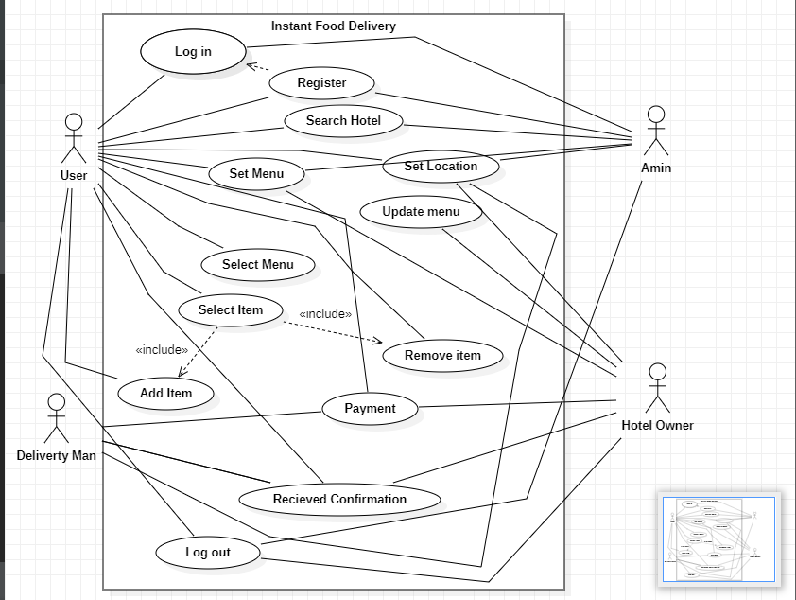

Supplementary Specification(Asher Khan Swati sp21-bse -044)
Non-functional These are some Requirements
- Maintainability:
- Serviceability
- Environmental
- Data Integrity
- Usability
- Scalability Reliability
- Recoverability
- Interoperability
- Capacity
- Performance
- Security
- Regulatory
- Availability
- Manageability

Glossary
An application often comparable in functionality to a desktop application. Which is accessed over a network, often view a web browser, rather than hosted on to user’s machine.

Risk List & Risk Management Plan(Asher Khan Swati sp21-bse -044)
1. Malware
Digital hackers are watching your every move and trick you to download malware and take control of your computer remotely. They use malware to attack computer networks to perpetrate crimes. Fraudsters use virus, malware, spyware, spams, and phishing to gain access to your sensitive personal information and commit financial crimes. Defend your data against malware through secure servers, whether physical or in cloud, and shield against vulnerabilities.

2. Theft & Loss
Unauthorized users without permissions who have access to sensitive data can cause harm to educational institutions as a result of theft. There is a risk of the sensitive academic data will be leaked by staff. It becomes easy to lose your storage media with backup data due to misplacement or theft. When you suffer data loss due to various incidents such as mechanical damage, power failure, software crash, disasters or loss of your laptops and mobile devices, it is another way of inadvertent data exposure. Keep all your data safe and secure using role-based access control to ensure confidentiality and privacy.

3. Unsafe data
If adequate safety precautions are not taken when files and documents are shared in website, smartphones and tablets via internet networks, the information contained on them might gain access to the devices and get exposed to risks. We can make use of cloud deployments to manage the education system better and better.

4. Negligence
When data is stored in computers or laptops, it has become so natural that people lose the information when files are accidentally deleted or even it could fall into the wrong hands. Ensure a proper backup strategy to keep your data on important devices and run them smoothly without hassles.

Brief level use case:

Asher khan swati (SP21-BSE-044)
Use Case: 5_login (Asher Khan Swati sp21-bse-044)
When the user interacts with login page and enter his id and password the system identify the id and password and then move to dashboard.
Use Case 6_Register (Asher Khan Swati sp21-bse-044)
Users register himself though their email address and create id and password then system
Identify their id and password and then move to dashboard.
Use case 7: Search Hotel (Asher Khan Swati sp21-bse-044)
After registration and login, the user search hotel near him and select item and make order.

Use Case 8: Add Item (Asher Khan Swati)
When User select item if he wants to add another item then user add his item in the cart and make order.
Use Case 9: Logout (Asher Khan Swati)
After the completion of order and payment the user logout the system.

Ahsan Ali (SP20-BSE-060)

Use Case: 1_ Order
User interaction with the order retrieval will be very simple. The application will automatically fetch new orders from the database at regular intervals and display the order numbers, along with delivery time, in a panel on the left-hand side of the application. To view the details of an order, the user must simply click on that order number, which will populate the right-hand panel with the details, displayed in an easy to read and navigate tree structure. This structure can intuitively be expanded and collapsed to display only the desired information. Finally, once and order is processed, the user clicks a single button, labelled “Processed”, to remove it from the list of active orders.

Use Case: 2_Menu
User interaction with the menu management system is similar to that with the web ordering system. Users navigate a tree structure to find the vendor, category, or specific food item that they would like to modify and after making their selection they are presented with a form which displays all of the current fields and values associated with that item, all of which can be modified or removed.

Use Case: 3_Payment
The user can pay the payment of his/her order on different ways e.g. (Jazz-Cash, Banking App, Cash, Easy-paisa) by using this application.

Use Case: 4_Location
The user can add the location this application. This app provides the functionality to build a bridge between the admin and the delivery boy. Through this Delivery boy app, the admin can manage the orders and assign them to the respective delivery.

Fully dressed use case:

Asher Khan Swati( Sp21-bse-044)

Use Case: 2_ Login
scope: customer login
primary Actors: customer, admin.
Stake holder and interest:
(Customer) Customers prefer using the food ordering app over ordering food online.
In this system customer can login the food easily at any time.
(Admin) Admin manage the whole application and also see the registeration of the customers.
Preconditions: Customer can login through this application.
Success guarantee (or Postconditions): Customer can order the food easily at any time.
Main success scenario or Basic flow:
- Customer can login through this application.
- Admin manage the whole application
- Customer can order the food easily at any time.
- Admin also see the order of the customers.
Extension or alternative flows:
If any time network can’t be working properly
- During the login, network can be working.
- Customer can phone call to the admin.
If system does not recover:
- The user will suspend the operation and the system will show an error message.
- The user starts a new operation and continue to his work.

Special requirements:
- The user can login the food by using this application.
- The application should connect to the admin.
Screen shot:
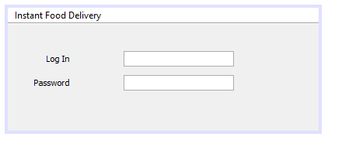

Use Case: 3_ Register
scope: customer register
primary Actors: customer, admin.
Stake holder and interest:
(Customer) Customers prefer using the food ordering app over ordering food online.
In this system customer can login the food easily at any time.
(Admin) Admin manage the whole application and also see the registeration of the customers.
Preconditions: Customer can register through this application.
Success guarantee (or Postconditions): Customer can order the food easily at any time.
Main success scenario or Basic flow:
- Customer can register through this application.
- Admin manage the whole application
- Customer can order the food easily at any time.
- Admin also see the order of the customers.
Screen shot:
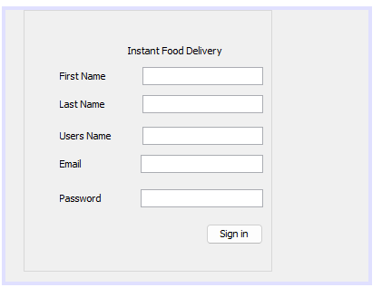

Use Case: 4_ Search hotel
scope: Search hotel
primary Actors: customer, admin.
Stake holder and interest:
(Customer) Customers prefer using the food ordering app over ordering food online.
In this system customer can search hotel the food easily at any time.
(Admin) Admin manage the whole application and also see the registeration of the customers.
Preconditions: Customer can search hotel through this application.
Success guarantee (or Postconditions): Customer can order the food easily at any time.
Main success scenario or Basic flow:
- Customer can register through this application.
- Admin manage the whole application
- Customer can order the food easily at any time.
- Admin also see the order of the customers.

Use Case: 5_ Add Item
scope: Add item
primary Actors: customer, admin.
Stake holder and interest:
(Customer) Customers prefer using the food ordering app over ordering food online.
In this system customer can search hotel the food easily at any time.
(Admin) Admin manage the whole application and also see the registeration of the customers.
Preconditions: Customer can add item in their menu through this application.
Success guarantee (or Postconditions): Customer can add item the food easily at any time.
Main success scenario or Basic flow:
- Customer can register through this application.
- Admin manage the whole application
- Customer can order the food easily at any time.
- Admin also see the order of the customers.

Use Case: 6_ logout
scope: log out
primary Actors: customer, admin.
Stake holder and interest:
(Customer) Customers prefer using the food ordering app over ordering food online.
In this system customer can search hotel the food easily at any time.
(Admin) Admin manage the whole application and also see the registeration of the customers.
Preconditions: Customer can log out through this application.
Success guarantee (or Postconditions): Customer can log out easily at any time.

Ahsan Ali (SP20-BSE-060)

Use Case: 1_ Order
scope: customer order
primary Actors: customer, admin.
Stake holder and interest:
(Customer) Customers prefer using the food ordering app over ordering food online.
In this system customer can order the food easily at any time.
(Admin) Admin manage the whole application and also see the order of the customers.
Preconditions: Customer can order through this application.
Success guarantee (or Postconditions): Customer can order the food easily at any time.
Main success scenario or Basic flow:
- Customer can order through this application.
- Admin manage the whole application
- Customer can order the food easily at any time.
- Admin also see the order of the customers.
Extension or alternative flows:
If any time network can’t be working properly
- During the order, network cannot be working.
- Customer can phone call to the admin.
If system does not recover:
- The user will suspend the operation and the system will show an error message.
- The user starts a new operation and continue to his work.

Special requirements:
- The user can order the food by using this application.
- The application should connect to the admin.

Technology and Data Variations List:
This application should connect to the restaurant.
After registration and login, the user search hotel near him and select item and make order.

Use Case: 2_Menu
scope: Customer select the items from menu.
primary Actors: Customer, admin.
Stake holder and interest:
(Customer) Customer select the items from menu by using this application.
(Admin) Admin manage the whole application and also see the order of the customers selected from the menu.
Preconditions: Customer can order or see the foods from the menu through this application.
Success guarantee (or Postconditions): Customer can see the food easily from menu at any time.
Main success scenario or Basic flow:
- Customer select the items from menu by using this application.
- Admin manage the whole application and also see the order of the customers selected from the menu.
- Customer can see the food easily from menu at any time.
Extension or alternative flows:
If any time network can’t be working properly
- During the menu viewing, network cannot be working.
- Customer can phone call to the admin for selection of food.
If system does not recover:
- The user will suspend the operation and the system will show an error message.
- The user starts a new operation and continue to his work.

Special requirements:
The user can view the menu of food by using this application.
The application should connect to the admin.

Technology and Data Variations List:
This application should connect to the restaurant.

Use Case: 3_Payment
scope: payment of order
primary Actors: customer, delivery boy and admin.
Stake holder and interest:
(Customer) The user can pay the payment of his/her order on different ways e.g. (Jazz-Cash, Banking App, Cash, Easy-paisa) by using this application.
(Delivery boy) The delivery boy can gets the payment of order from the customer by different ways e.g. (Jazz-Cash, Banking App, Cash, Easy-paisa) by using this application.
(Admin) Amin can check the confirmation of payment of the order.
Preconditions: Customer can pay easily.
Success guarantee (or Postconditions): The user can pay the payment of his/her order on different ways e.g. (Jazz-Cash, Banking App, Cash, Easy-paisa) by using this application.
Main success scenario or Basic flow:
- The user can pay the payment of his/her order on different ways e.g. (Jazz-Cash, Banking App, Cash, Easy-paisa) by using this application.
- The delivery boy can gets the payment of order from the customer.
- Amin can check the confirmation of payment of the order.
- The customer can pay at any time

Extension or alternative flows:
If any time network can’t be working properly
- Then the delivery boy can got the payment of order from the customer by hand (Cash).
If system does not recover:
- The user will suspend the operation and the system will show an error message.
- The user starts a new operation and continue to his work.
Special requirements:
- The user can pay by using banking app at any time.
- The application should connect to the admin.

Technology and Data Variations List:
This application should connect to the restaurant.
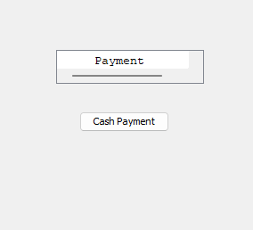

Use Case: 4_ Location
Scope: Set location
primary Actors: Delivery boy, hotel owner, Customer, Admin.
Stake holder and interest:
(Customer) The user can add the location this application.
(Delivery boy) & (Admin) This app provides the functionality to build a bridge between the admin and the delivery boy.
Preconditions: Customer set location easily.
Success guarantee (or Postconditions):
Through this Delivery boy app, the admin can manage the orders and assign them to the respective delivery.
Main success scenario or Basic flow:
- The user can add the location this application.
- Delivery boy & Admin This app provides the functionality to build a bridge between the admin and the delivery boy.
Extension or alternative flows:
If any time network can’t be working properly.
- The delivery boy can call the customer to his/her given number.
Special requirements:
- The user can order and set the location.
- The application should connect to the admin.
Technology and Data Variations List:
This application should connect to the restaurant.

CHAPTER _Physical Database Design

Ahsan Ali (SP20-Bse-060)

Project SQL Script File - Version 1

Provide a link to your cloud storage .sql script file here, which should do the following:
- Create Database if not exist
- Create all tables in your project along with primary and foreign keys
  - Note: Every group member should create their own tables in the file along with registration and name on top in comments
- Feed Sample data to all tables.
  - Note: Every group member should feed sample realistic data in respective tables in the file along with registration and name on top in comments
- What was the difficult part in creating this assignment?
  - Every group member should define their own area.
- Generate information from your table by relating them to tables of other group members as well. You will have to write at least 5 meaningful simple, average and complex queries
Every group member should define their own area.

Chapter 3 SSDs:

Asher Khan Swati (SP21-BSE-044)

Add item:

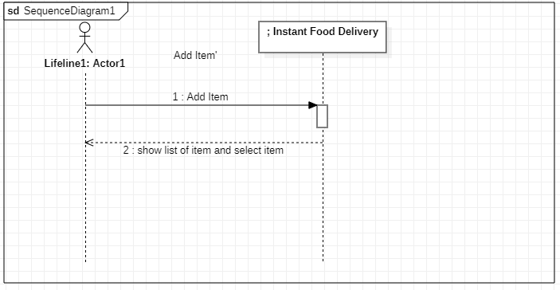

Search Hotel:
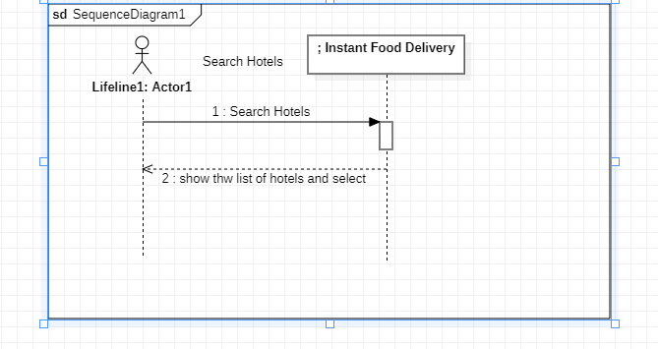

Log In:

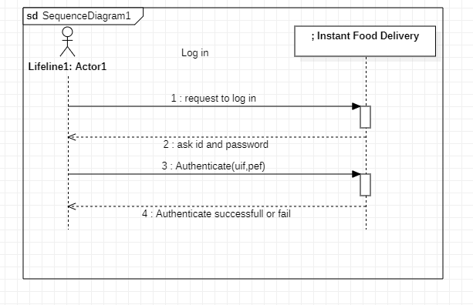

Log Out:
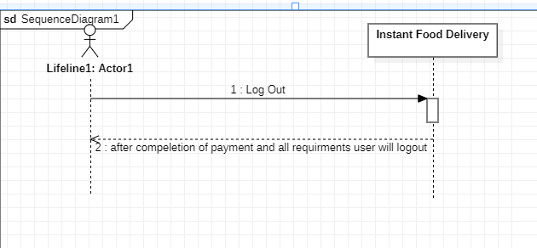

Package Diagram:

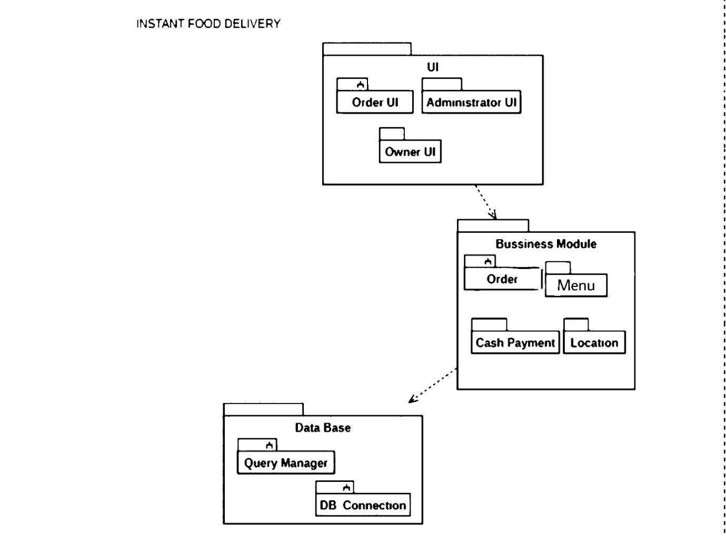

CHAPTER 2 SSDs

Ahsan Ali (SP20-Bse-060)

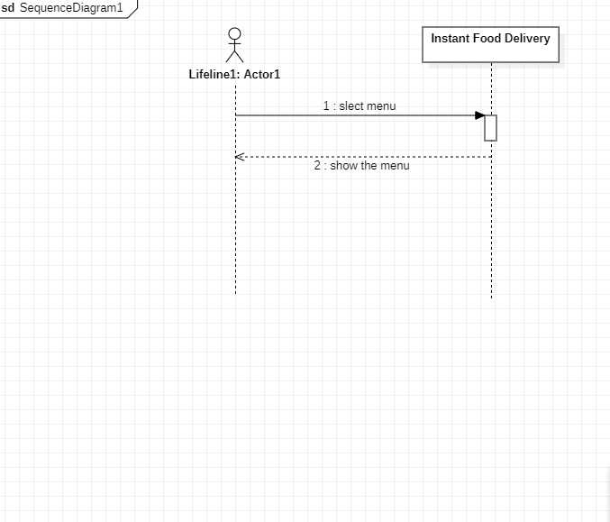
SSDs 1_Menu

SSDs 2_ location

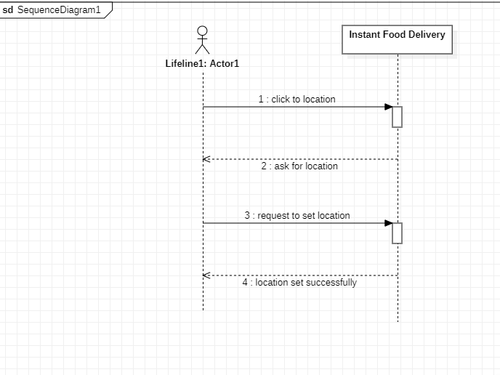

SSDs 3_Order
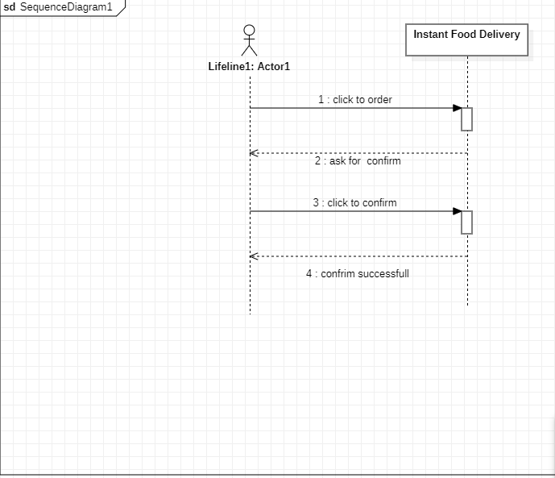

Class Diagram

Ahsan Ali (SP20-Bse-060)

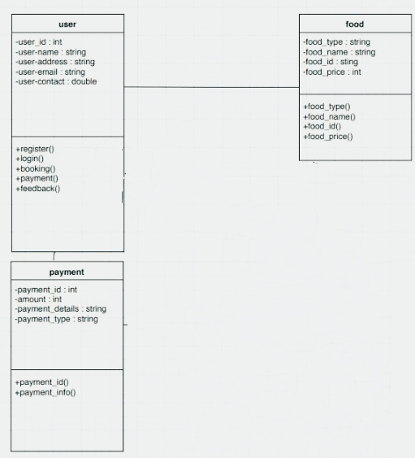

Iteraction Diagram

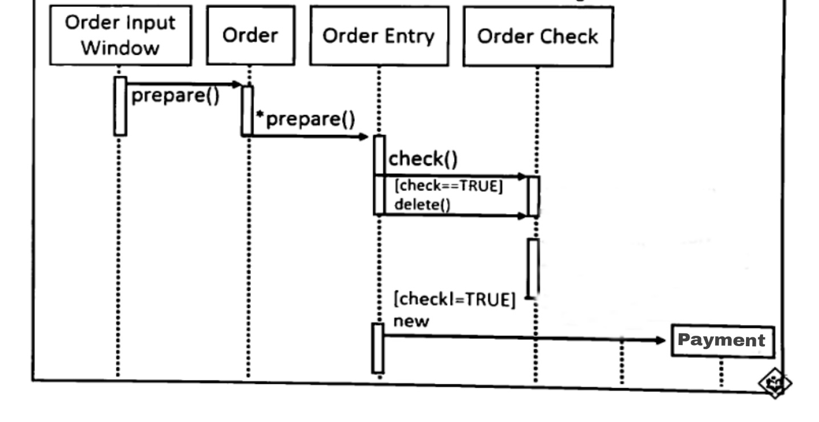
Ahsan Ali (SP20-Bse-060)

Chapter 4 Gui Interfaces

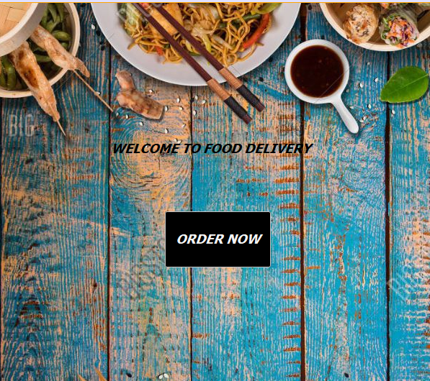
GUI 1_Order

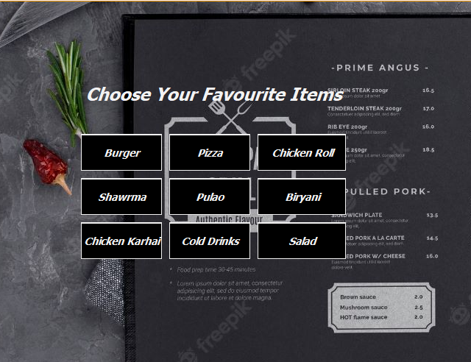
GUI 2_Menu

GUI 3_Confirm
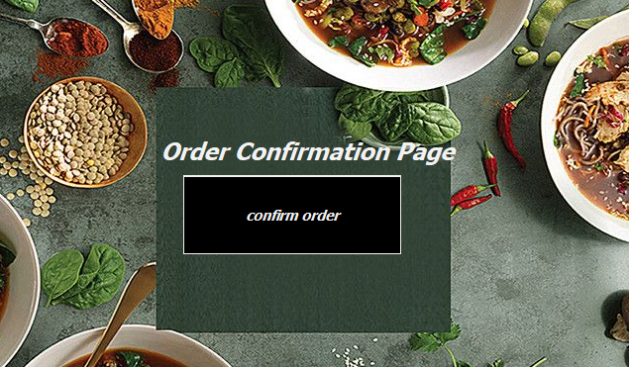

Sequence _ Diagram

Ahsan Ali (SP20-Bse-060)
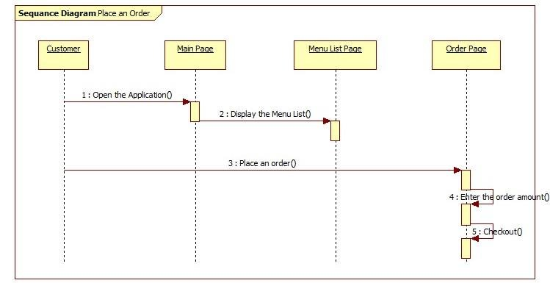

ER Diagram

Ahsan Ali (SP20-Bse-060)

ER Diagram 1_Order

